由可知，半径趋向于0时，压强差趋向于正无穷~~~

声光现象：

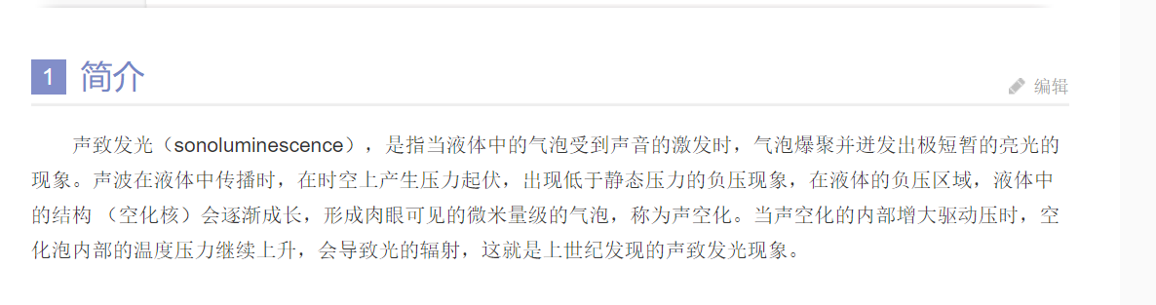

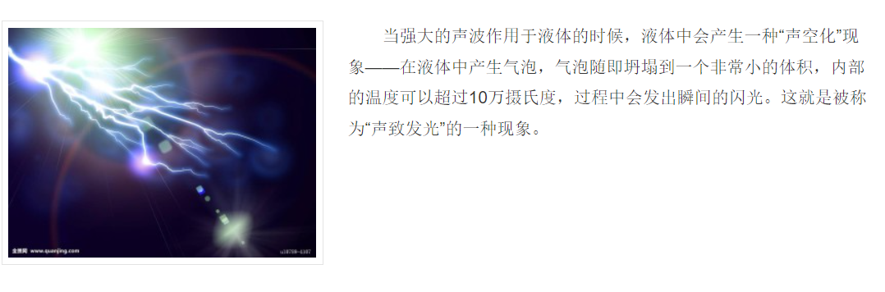

具体参考html文件，声光现象

或者访问链接[声光现象 - 搜狗百科 (sogou.com)](https://baike.sogou.com/v70417239.htm#:~:text=%E5%A3%B0%E8%87%B4%E5%8F%91%E5%85%89%EF%BC%88sonoluminescence%EF%BC%89%EF%BC%8C%E6%98%AF%E6%8C%87%E5%BD%93%E6%B6%B2%E4%BD%93%E4%B8%AD%E7%9A%84%E6%B0%94%E6%B3%A1%E5%8F%97%E5%88%B0%E5%A3%B0%E9%9F%B3%E7%9A%84%E6%BF%80%E5%8F%91%E6%97%B6%EF%BC%8C%E6%B0%94%E6%B3%A1%E7%88%86%E8%81%9A%E5%B9%B6%E8%BF%B8%E5%8F%91%E5%87%BA%E6%9E%81%E7%9F%AD%E6%9A%82%E7%9A%84%E4%BA%AE%E5%85%89%E7%9A%84%E7%8E%B0%E8%B1%A1%E3%80%82%20%E5%A3%B0%E6%B3%A2%E5%9C%A8%E6%B6%B2%E4%BD%93%E4%B8%AD%E4%BC%A0%E6%92%AD%E6%97%B6%EF%BC%8C%E5%9C%A8%E6%97%B6%E7%A9%BA%E4%B8%8A%E4%BA%A7%E7%94%9F%E5%8E%8B%E5%8A%9B%E8%B5%B7%E4%BC%8F%EF%BC%8C%E5%87%BA%E7%8E%B0%E4%BD%8E%E4%BA%8E%E9%9D%99%E6%80%81%E5%8E%8B%E5%8A%9B%E7%9A%84%E8%B4%9F%E5%8E%8B%E7%8E%B0%E8%B1%A1%EF%BC%8C%E5%9C%A8%E6%B6%B2%E4%BD%93%E7%9A%84%E8%B4%9F%E5%8E%8B%E5%8C%BA%E5%9F%9F%EF%BC%8C%E6%B6%B2%E4%BD%93%E4%B8%AD%E7%9A%84%E7%BB%93%E6%9E%84,%EF%BC%88%E7%A9%BA%E5%8C%96%E6%A0%B8%EF%BC%89%E4%BC%9A%E9%80%90%E6%B8%90%E6%88%90%E9%95%BF%EF%BC%8C%E5%BD%A2%E6%88%90%E8%82%89%E7%9C%BC%E5%8F%AF%E8%A7%81%E7%9A%84%E5%BE%AE%E7%B1%B3%E9%87%8F%E7%BA%A7%E7%9A%84%E6%B0%94%E6%B3%A1%EF%BC%8C%E7%A7%B0%E4%B8%BA%E5%A3%B0%E7%A9%BA%E5%8C%96%E3%80%82%20%E5%BD%93%E5%A3%B0%E7%A9%BA%E5%8C%96%E7%9A%84%E5%86%85%E9%83%A8%E5%A2%9E%E5%A4%A7%E9%A9%B1%E5%8A%A8%E5%8E%8B%E6%97%B6%EF%BC%8C%E7%A9%BA%E5%8C%96%E6%B3%A1%E5%86%85%E9%83%A8%E7%9A%84%E6%B8%A9%E5%BA%A6%E5%8E%8B%E5%8A%9B%E7%BB%A7%E7%BB%AD%E4%B8%8A%E5%8D%87%EF%BC%8C%E4%BC%9A%E5%AF%BC%E8%87%B4%E5%85%89%E7%9A%84%E8%BE%90%E5%B0%84%EF%BC%8C%E8%BF%99%E5%B0%B1%E6%98%AF%E4%B8%8A%E4%B8%96%E7%BA%AA%E5%8F%91%E7%8E%B0%E7%9A%84%E5%A3%B0%E8%87%B4%E5%8F%91%E5%85%89%E7%8E%B0%E8%B1%A1%E3%80%82)

And

